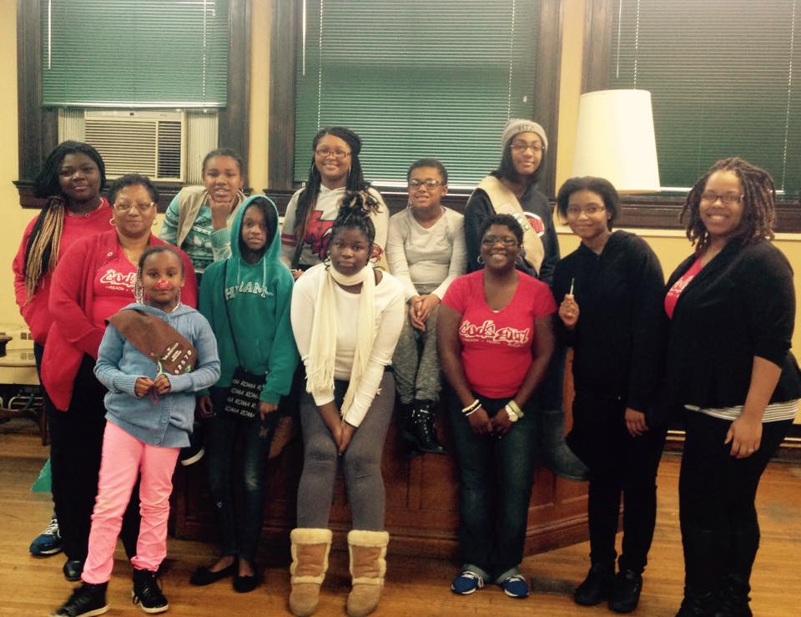

Dec. 25, 2014

Jan 1, 2014

Contact us at [www.godsgurl.org](http://www.godsgurl.org) or 866-295-5546

God’s Gurl is a federally recognized 501(c)3 organization with a n all volunteer staff and we need your help to continue serving women an girls! We currently serve the Greater Pittsburgh area, PA and St. Louis, MO including the Metro East and surrounding area.

For PA givers, go to <http://www.3riverscfc.org/> Other areas: we are apart of the Universal Giving Program.

#### Combined Federal Campagin #47116

Psalm 45:13 The King’s daughter is honorable in all..

# Storing Up Treasures

Although the Bible instructs believers to store up heavenly treasures, the young ladies of Braddock Girl Scout Troop 52570 are learning the practical of securing a strong financial future for themselves. God’s Gurl (GG) is excited to embark on this journey with them. Each quarter, GG staff meets with the girls to teach them practical life skills on Giving, Saving, Investing and Budgeting. They receive an extensive financial literacy teaching that helps them understand how to prioritize their money and begin saving. Each lesson has a creative openers, interactive discussions and hand=on activities that allow the young ladies to practices their skills. The young ladies are required to complete independent activities as they progress through the course. The girls will have the opportunity to earn a Financial Literacy Badge upon successful completion of the entire course.

MERRY CHRISTMAS!!

HAPPY NEW YEAR!!

Girl Scout Troop Meeting,

Pittsburgh, PA

Monthly Empower Lunch,

Fairview Heights, IL

GG. STL Financial Literacy Seminar,

Belleville, IL

Jan. 2014

Nov. 1, 2014

Feb. 2014

## Upcoming Events

God’s Gurl

Issue 1, November 2014

Building an Inheritance!

Girls Scout Troop 52570, of Braddock, Pa and GG Pittsburgh have partnered to equip these young ladies to prepare for financially successful futures!

Reach. Teach. Build.